SQL Assignment 4

3. write a SQL query to Create Stored procedure in the Northwind database to retrieve

Sales by Year.

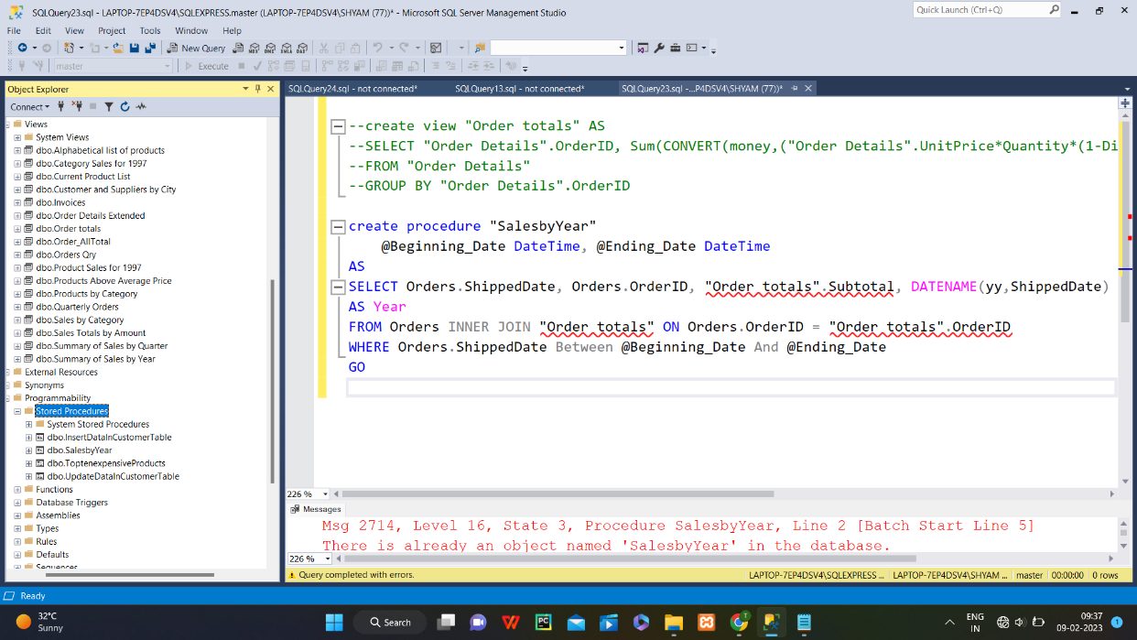

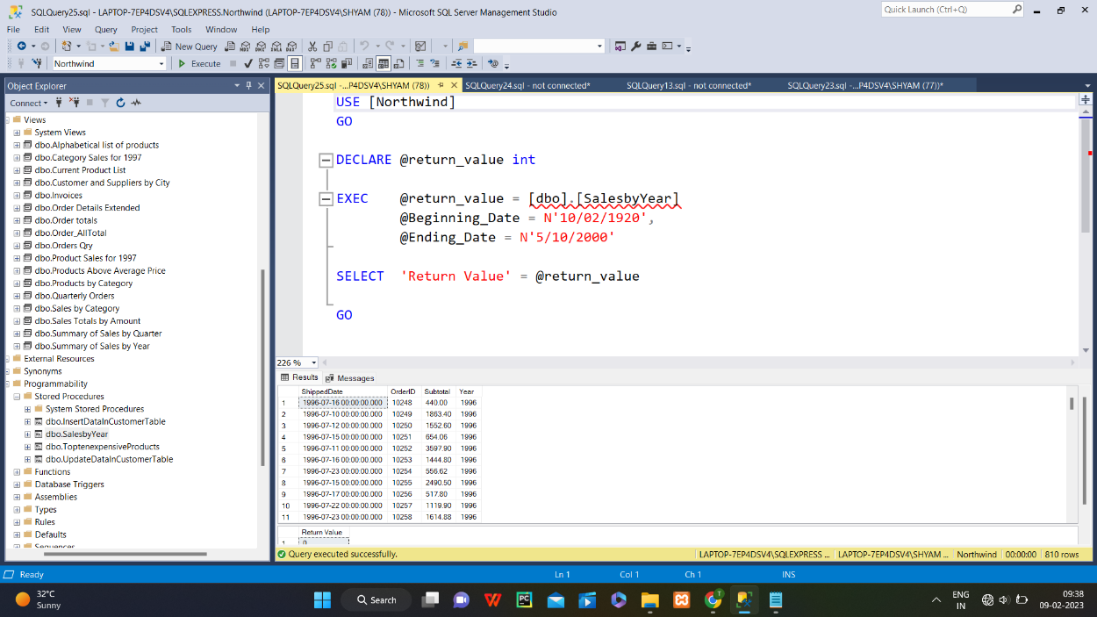

4. write a SQL query to Create Stored procedure in the Northwind database to retrieve

Sales By Category.

5. write a SQL query to Create Stored procedure in the Northwind database to retrieve

Ten Most Expensive Products.

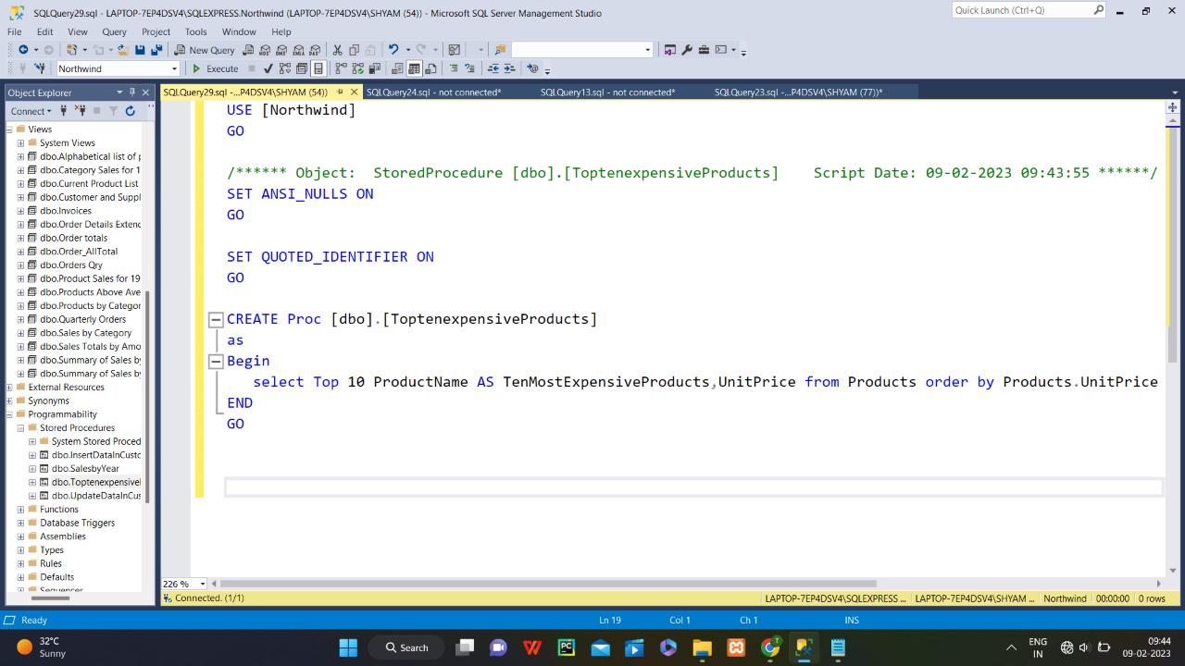

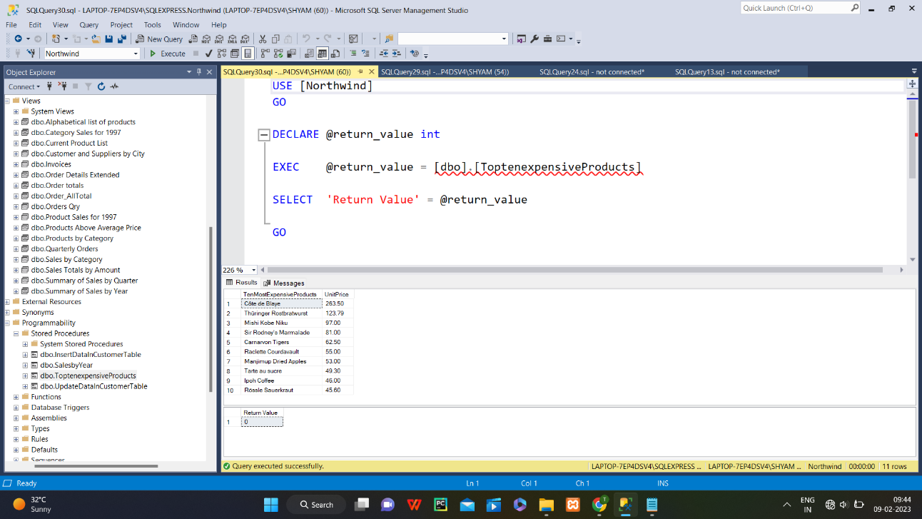

6. write a SQL query to Create Stored procedure in the Northwind database to insert

Customer Order Details.

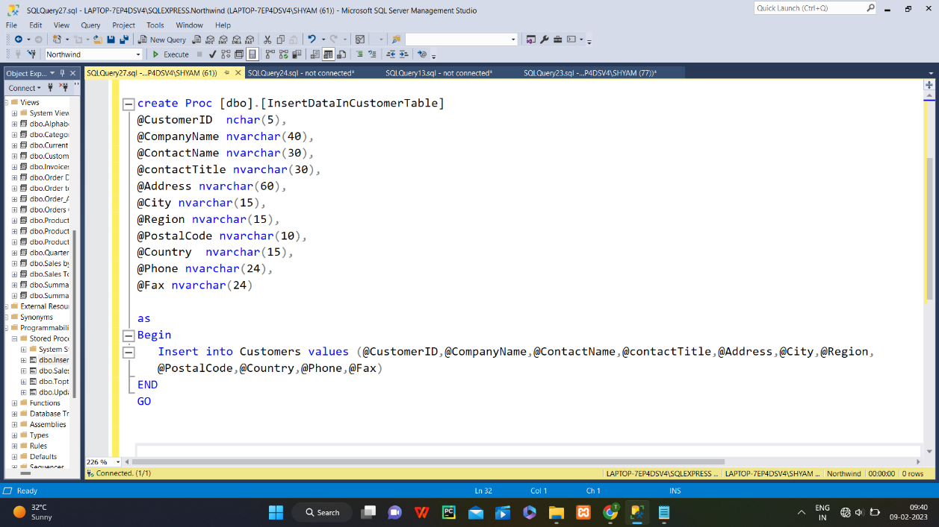

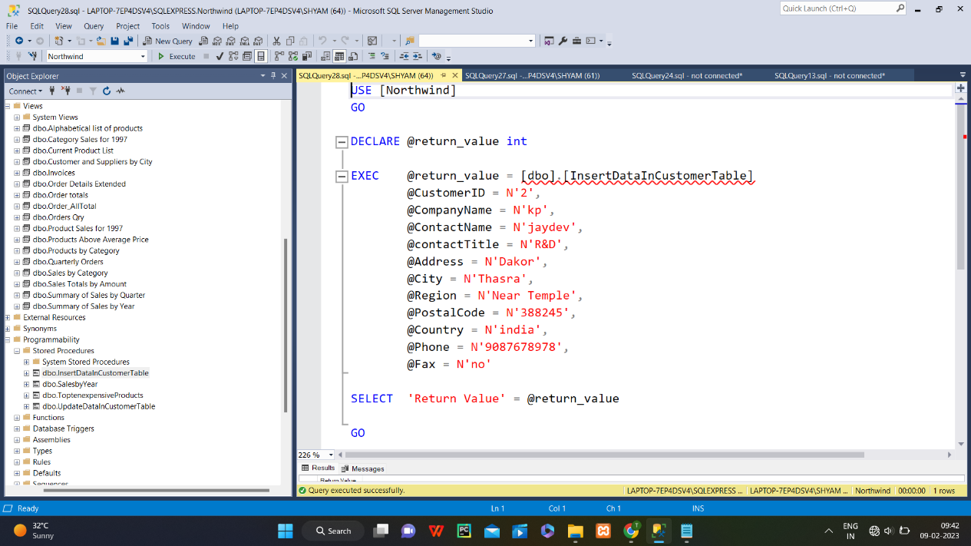

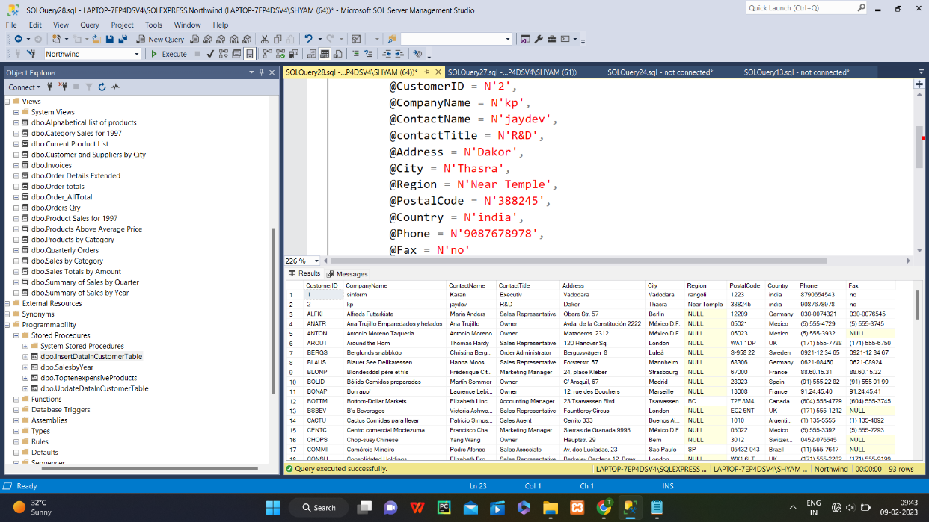

7. write a SQL query to Create Stored procedure in the Northwind database to update

Customer Order Details.

